8 channel Rail RS485 Relay commamd
1 This version has 2 Command modes, MODBUS RTU Command and AT Command. 2 The default Command is the MODBUS RTU Command, compatible with older versions.
3 Switch to AT command by shorting the M0 pad.
4 The default baud rate is 9600BPS. You can also select the baud rate by shorting the M1 and M2 pads.
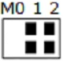 | 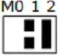 | 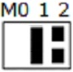 | 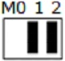
9600BPS(default) | 2400BPS | 4800BPS | 19200BPS

MODBUS Command (function code 06 is Control command,03 is Read status command)

Note :
1 MODBUS command must be HEX
2 Slave ID (device address) must be consistent with the DIP switches (A0-A5)
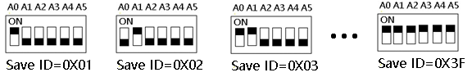
3 Jumper switch status: M0's two pads must be disconnected , as shown 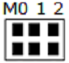
9600 Band ,8 Data bits,None Parity,1 Stop Bit。
MODBUS 06 Command (Control command ,HEX):
Bytes Number | 1 | 2 | 3 | 4 | 5 | 6 | 7 | 8
MODBUS Definitions | Slave ID | Function | Address |  | Data |  | CRC Check
Function | Device Address | Function | Channel number |  | Command | Delay time | CRC Check
Open | 0x00-0x2F | 0x06 | 0x0001-  0x0008 |  | 0x01 | 0x00 | 2Bytes CRC
Close | 0x00-0x2F | 0x06 | 0x0001-  0x0008 |  | 0x02 | 0x00 | 2Bytes CRC
Toggle (Self-locking) | 0x00-0x2F | 0x06 | 0x0001-  0x0008 |  | 0x03 | 0x00 | 2Bytes CRC
Latch Inter-locking) | 0x00-0x2F | 0x06 | 0x0001-  0x0008 |  | 0x04 | 0x00 | 2Bytes CRC
Momentary (Non-locking) | 0x00-0x2F | 0x06 | 0x0001-  0x0008 |  | 0x05 | 0x00 | 2Bytes CRC
Delay | 0x00-0x2F | 0x06 | 0x0001-  0x0008 |  | 0x06 | 0x00-0xff | 2Bytes CRC
Open all | 0x00-0xFE | 0x06 | 0x0000 |  | 0x07 | 0x00 | 2Bytes CRC
Close all | 0x00-0xFE | 0x06 | 0x0000 |  | 0x08 | 0x00 | 2Bytes CRC

Remarks:
1 Momentary mode, delay time is 1 seconds
2 Delay mode, delay time is 0-255 seconds

Return command：
Command is active, return to send com
mands; instruction is invalid no return.

MODBUS 03 Command (Read status command ,HEX):
Bytes Number | 1 | 2 | 3 | 4 | 5 | 6 | 7 | 8
MODBUS Definitions | Slave ID | Function | Address |  | Data |  | CRC Check
Function | Device Address | Function | Starting register address |  | Register length |  | CRC Check
Read Channel 1 State | 0x00-0x2F | 0x03 | 0x0001 |  | 0x0001
Read Channel 2 State | 0x00-0x2F | 0x03 | 0x0002 |  | 0x0001
Read 2 consecutive channels status | 0x00-0x2F | 0x03 | 0x0001-0x0003 |  | 0x0002
Read 3 consecutive channels status | 0x00-0x2F | 0x03 | 0x0001-0x0002 |  | 0x0003
Read all 8 channels status | 0x00-0x2F | 0x03 | 0x0001 |  | 0x0008

Read status command returns (function code 03, HEX format):
Bytes length | 1 | 1 | 1 |  | 2
MODBUS Definitions | Slave ID | Function | data length | data | CRC16 Check
Function | Device Address | Function | data length | Relay state  0x0001 open  0x0000 close | CRC16 Check
Channel 1  open | 0x00-0x1F | 0x03 | 0x02 | 0x0001
Channel 1  close | 0x00-0x1F | 0x03 | 0x02 | 0x0000
Channel 2  open | 0x00-0x1F | 0x03 | 0x02 | 0x0001
Channel 2  close | 0x00-0x1F | 0x03 | 0x02 | 0x0000
Channel 1 open  Channel 2 open | 0x00-0x1F | 0x03 | 0x04 | 0x0001 0x0001
Channel 1 open  Channel 2 close | 0x00-0x1F | 0x03 | 0x04 | 0x0001 0x0000
Channel 1 close  Channel 2 open | 0x00-0x1F | 0x03 | 0x04 | 0x0000 0x0001
Channel 1 close  Channel 2 close | 0x00-0x1F | 0x03 | 0x04 | 0x0000 0x0000

MODBUS commands you can use "Modbus Poll" input, as shown below
（CRC check generated automatically）
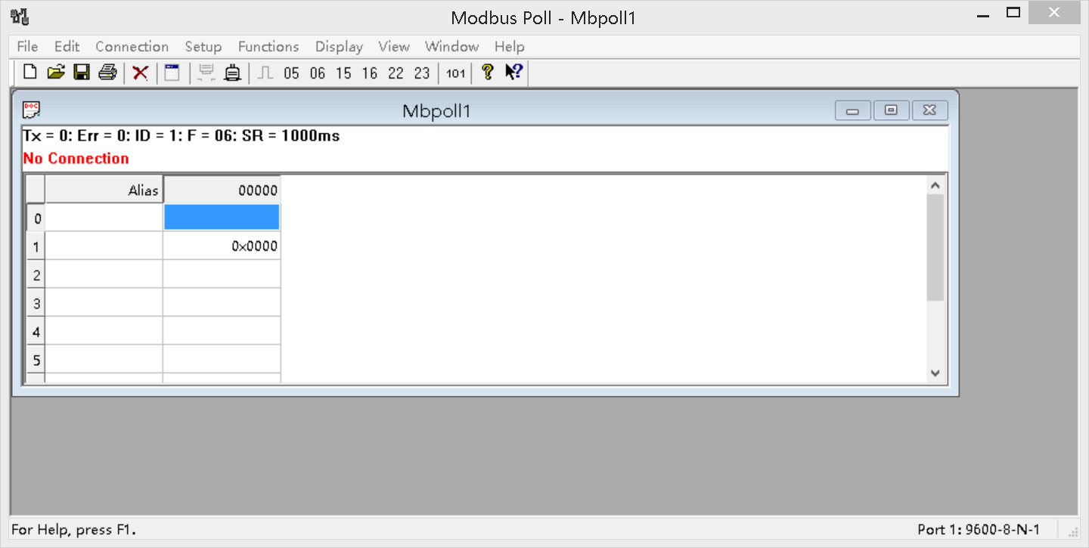
You can also use HyperTerminal serial input, as shown below
（Manually add CRC check）
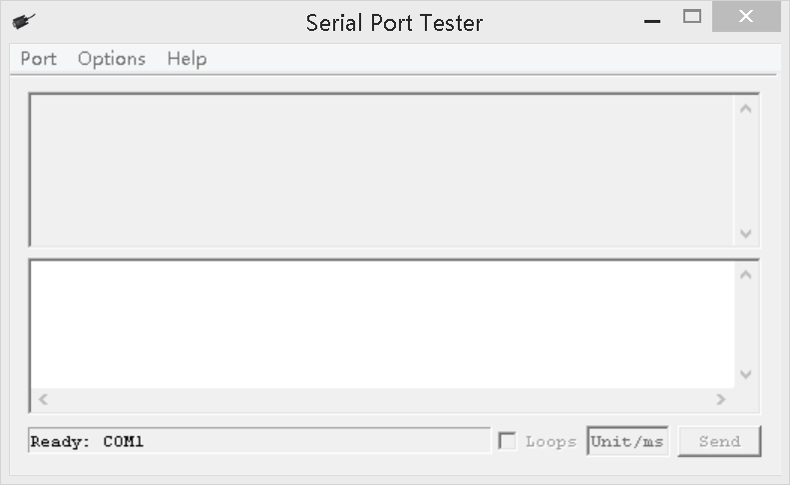

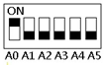
Examples (Slave ID is 1,DIP switch state)
Channel 1 Open ：01 06 00 01 01 00 D9 9A
Channel 1 Close ：01 06 00 01 02 00 D9 6A
Channel 1 Toggle：01 06 00 01 03 00 D8 FA
Channel 1 Latch：01 06 00 01 04 00 DA CA
Channel 1 Momentary: 01 06 00 01 05 00 DB 5A
Channel 1 Delay 10 seconds : 01 06 00 01 06 0A 5B AD
Channel 1 Delay 100 seconds: 01 06 00 01 06 64 DA 41

Channel 2 Open ：01 06 00 02 01 00 29 9A
Channel 2 Close ：01 06 00 02 02 00 29 6A
Channel 2 Toggle ：01 06 00 02 03 00 28 FA
Channel 2 Latch ：01 06 00 02 04 00 2A CA
Channel 2 Momentary : 01 06 00 02 05 00 2B 5A
Channel 2 Delay 10 seconds : 01 06 00 02 06 0A AB AD
Channel 2 Delay 100 seconds : 01 06 00 02 06 64 2A 41

Open all：01 06 00 00 07 00 8B FA
Close all：01 06 00 00 08 00 8E 0A

Read state (assuming that the channel 1 is open, the channel 2 is close).
Read channel 1 state ：01 03 00 01 00 01 D5 CA
Return open：01 03 02 00 01 79 84

Read channel 2 state ：01 03 00 02 00 01 25 CA
Return close：01 03 02 00 00 B8 44

Read channel 1 and channel 2 state ：01 03 00 01 00 02 95 CB
Return channel open and channel 2 close ：01 03 04 00 01 00 00 AB F3

AT command (ASCII characters)

Note:
1 In the AT command mode slave ID is invalid
2 AT commands must be uppercase, lowercase invalid
3 Jumper switch status: M0's two pads are soldered together, as shown 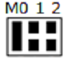
9600 Band ,8 Data bits,None Parity,1 Stop Bit

Read Status:
Channel 1: AT+R1
Channel 2: AT+R2
Channel 3: AT+R3
Channel 4: AT+R4
Channel 5: AT+R5
Channel 6: AT+R6
Channel 7: AT+R7
Channel 8: AT+R8

Open :
Channel 1 : AT+O1
Channel 2 : AT+O2
Channel 3: AT+O3
Channel 4: AT+O4
Channel 5: AT+O5
Channel 6: AT+O6
Channel 7: AT+O7
Channel 8: AT+O8

Close:
Channel 1 : AT+C1
Channel 2 : AT+C2
Channel 3 : AT+C3
Channel 4 : AT+C4
Channel 5: AT+C5
Channel 6: AT+C6
Channel 7: AT+C7
Channel 8: AT+C8

Toggle (Self-locking)
Channel 1: AT+T1
Channel 2: AT+T2
Channel 3: AT+T3
Channel 4: AT+T4
Channel 5: AT+T5
Channel 6: AT+T6
Channel 7: AT+T7
Channel 8: AT+T8

Latch (Inter-locking)
Channel 1: AT+L1
Channel 2: AT+L2
Channel 3: AT+L3
Channel 4: AT+L4
Channel 5: AT+L5
Channel 6: AT+L6
Channel 7: AT+L7
Channel 8: AT+L8

Momentary (Non-locking)
Channel 1: AT+M1
Channel 2: AT+M2
Channel 3: AT+M3
Channel 4: AT+M4
Channel 5: AT+M5
Channel 6: AT+M6
Channel 7: AT+M7
Channel 8: AT+M8

Delay
Channel 1: AT+D1=XXXX
Channel 2: AT+D2=XXXX
Channel 3: AT+D3=XXXX
Channel 4: AT+D4=XXXX
Channel 5: AT+D5=XXXX
Channel 6: AT+D6=XXXX
Channel 7: AT+D7=XXXX
Channel 8: AT+D8=XXXX

XXXX refers to the 0000 to 9999 figures, Unit is seconds

All Relays Open
AT+AO

All Relays Close
AT+AC

Return command : OpenX, CloseX (X = 1/2/3/4/5/6/7/8)

Example 1:
Send command "AT+D1=0010", Channel 1 is "Open", after delay of 10 seconds, channel 1 is "Close"
Send command "AT+D2=0100", Channel 2 is "Open", after delay of 100 seconds, channel 2 is "Close"

Example 2:
Send command "AT+L1", Channel 1 is "Open", other Channels is "Close"
Send command "AT+L2", Channel 2 is "Open", other Channels is "Close"

